EVENT BOOKING

AND MENU

The Elmwood Golf Club first opened its course for play in 1917. Within the following 10 years the course was completely redesigned by Bill Brinkworth. At the time of the redesign, elmwood (which lies alongside Swift Current Creek) was reported to be one of the premier 18 hole layouts in western Canada. Through the many years since that time, this beautiful course has lost none of its grandeur.
With a recent redesign by acclaimed architect Les Furber, Elmwood Golf Club boasts a rare layout that manages to both challenge seasoned players while helping newcomers relax as they learn the game. Play at elmwood combines stunning, rolling terrain with a knowledgeable staff and expert grounds maintenance. Our multiple tee decks cater to players of all ages and skill levels. Elmwood golf club offers one of the best award-winning junior golf programs in all of Canada.
Enjoy a delicious brunch overlooking one of Saskatchewan’s most famous golf courses! Elmwood golf club is known for our excellent food, great service and outstanding hospitality. Perfect for spending time with friends and family, welcoming out-of-town guests or special celebrations such as weddings, anniversaries or birthdays.
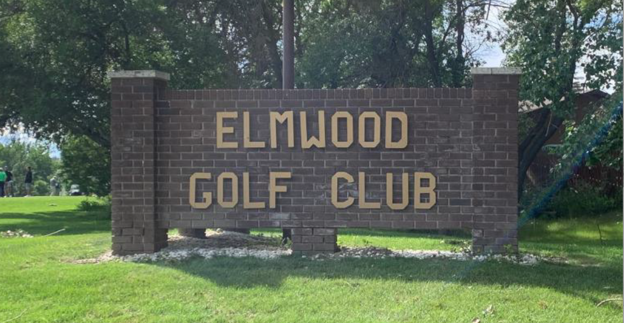

Elmwood breakfast buffet
Group Name: ...............................................................................
Event Name: .................................................................................
Contact Name: ............................................................................
Number of Guests: ...................................................................
Contact Number: ......................................................................
Service Time: ..............................................................................
Signature: _________________________(2023)
MINIMUM RESERVATION 20 PERSONS
** All prices ARE PER PERSON AND are subject to applicable taxes. Elmwood Golf Club adds 15% for gratuity to all food (not alcoholic beverages) for banquet/event bookings**. 7 DAYS CONFIRMATION IS REQUIRED FOR BILLING PURPOSES. PLEASE EMAIL FORM TO LOUIED@SASKTEL.NET
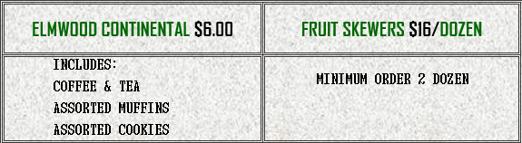
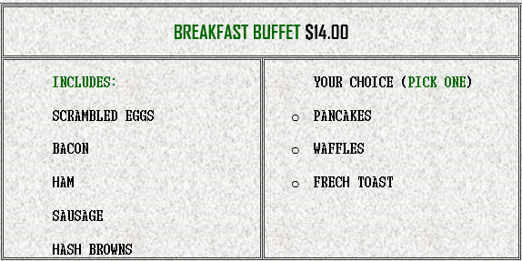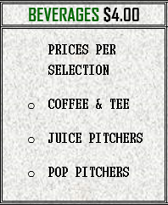
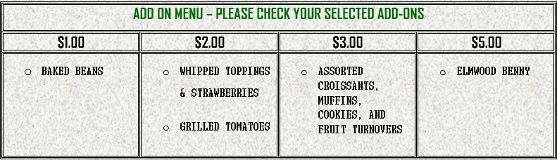

SPECIAL REQUESTS _____________________________________________
BBQ and Buffet Menu
Group Name: ...............................................................................
Event Name: .................................................................................
Contact Name: ............................................................................
Number of Guests: ...................................................................
Contact Number: ......................................................................
Service Time: ..............................................................................
Signature: _________________________(2023)

** All prices ARE PER PERSON AND are subject to applicable taxes. Elmwood Golf Club adds 15% for gratuity to all food (not alcoholic beverages) for banquet/event bookings**. 7 DAYS CONFIRMATION IS REQUIRED FOR BILLING PURPOSES. PLEASE EMAIL FORM TO LOUIED@SASKTEL.NET
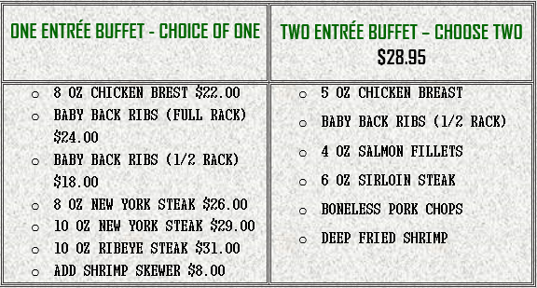
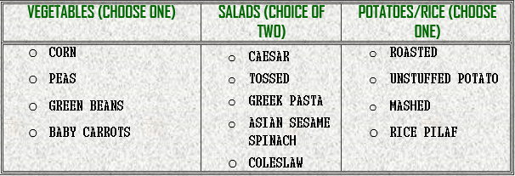
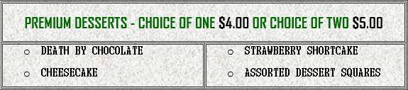
SPECIAL REQUESTS _____________________________________________
Lunch Buffet Menu
Group Name: ...............................................................................
Event Name: .................................................................................
Contact Name: ............................................................................
Number of Guests: ...................................................................
Contact Number: ......................................................................
Service Time: ..............................................................................
Signature: _________________________(2023)

** All prices ARE PER PERSON AND are subject to applicable taxes. Elmwood Golf Club adds 15% for gratuity to all food (not alcoholic beverages) for banquet/event bookings**. 7 DAYS CONFIRMATION IS REQUIRED FOR BILLING PURPOSES. PLEASE EMAIL FORM TO LOUIED@SASKTEL.NET
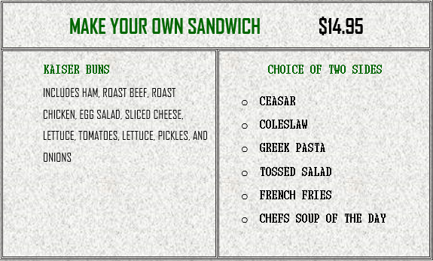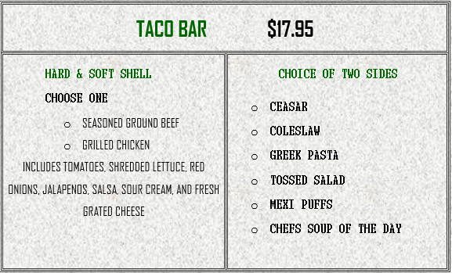

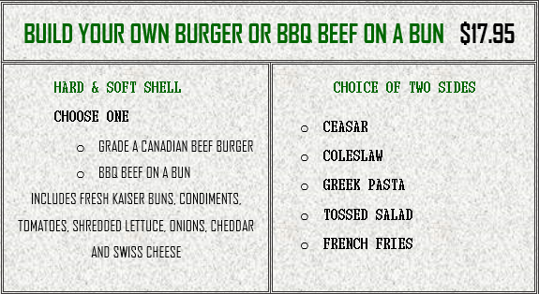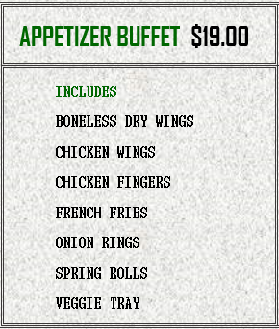

SPECIAL REQUESTS _____________________________________________
ENTRÉE Menu
Group Name: ...............................................................................
Event Name: .................................................................................
Contact Name: ............................................................................
Number of Guests: ...................................................................
Contact Number: ......................................................................
Service Time: ..............................................................................
Signature: _________________________(2023)

** All prices ARE PER PERSON AND are subject to applicable taxes. Elmwood Golf Club adds 15% for gratuity to all food (not alcoholic beverages) for banquet/event bookings**. 7 DAYS CONFIRMATION IS REQUIRED FOR BILLING PURPOSES. PLEASE EMAIL FORM TO LOUIED@SASKTEL.NET
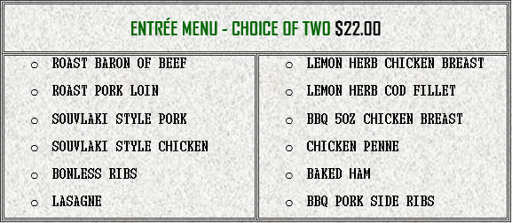

SPECIAL REQUESTS _____________________________________________
COCKTAIL PARTY MENU
Group Name: ...............................................................................
Event Name: .................................................................................
Contact Name: ............................................................................
Number of Guests: ...................................................................
Contact Number: ......................................................................
Service Time: ..............................................................................
Signature: _________________________(2023)

** All prices ARE PER PERSON AND are subject to applicable taxes. Elmwood Golf Club adds 15% for gratuity to all food (not alcoholic beverages) for banquet/event bookings**. 7 DAYS CONFIRMATION IS REQUIRED FOR BILLING PURPOSES. PLEASE EMAIL FORM TO LOUIED@SASKTEL.NET

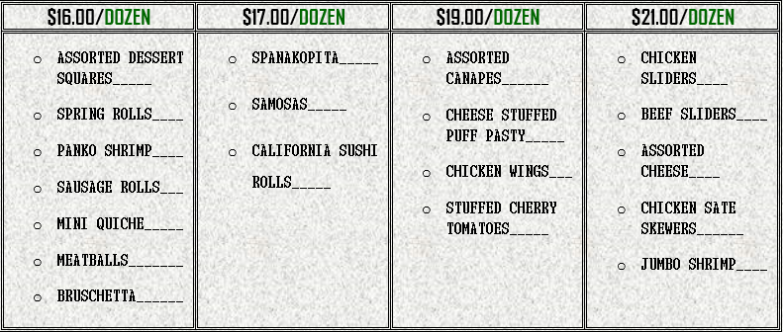

*MINIMUM ORDER OF EACH SELECTION IS TWO DOZEN

SPECIAL REQUESTS _____________________________________________

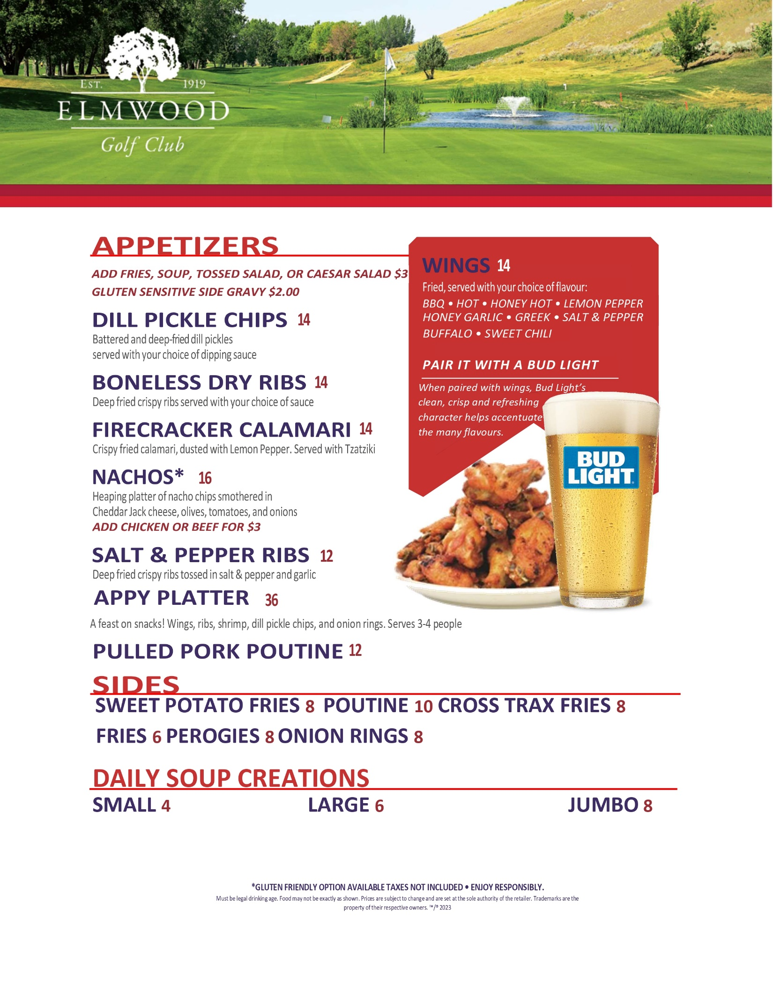
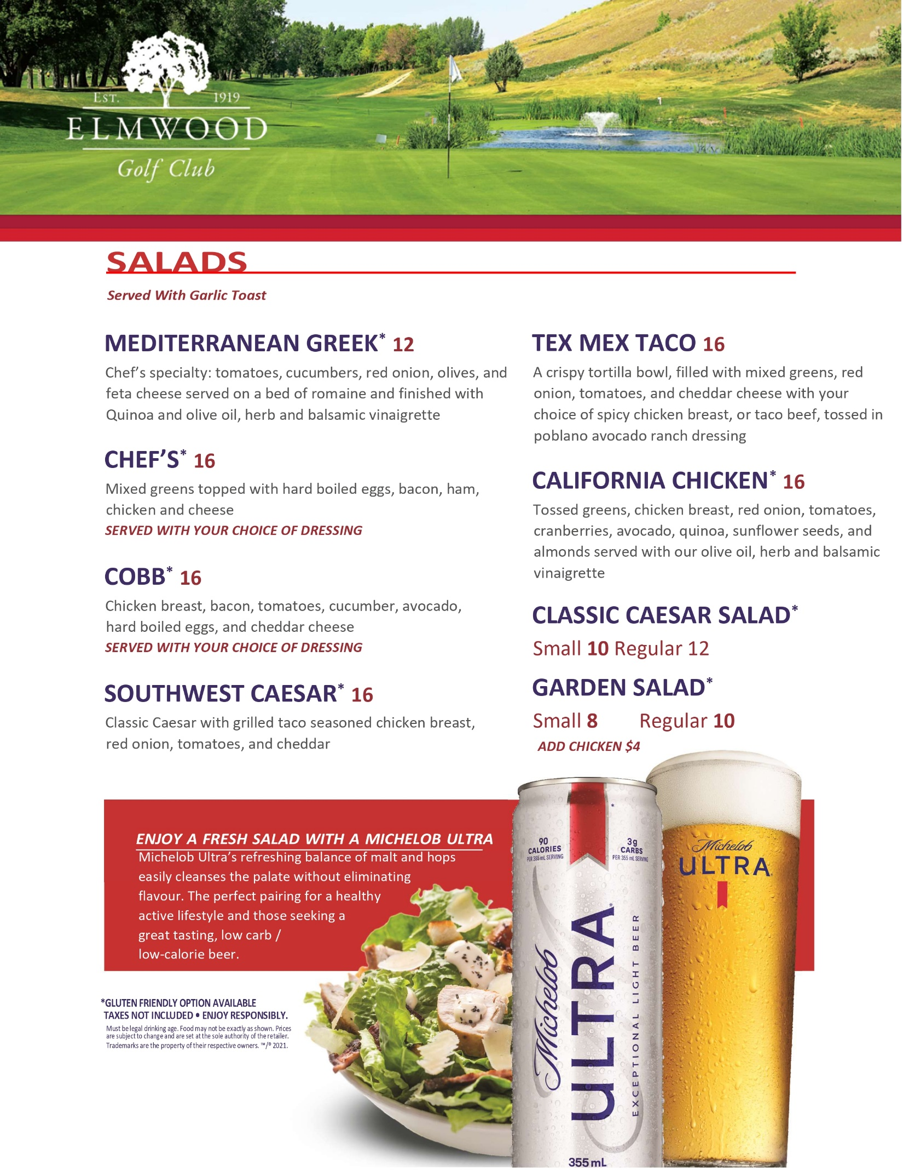
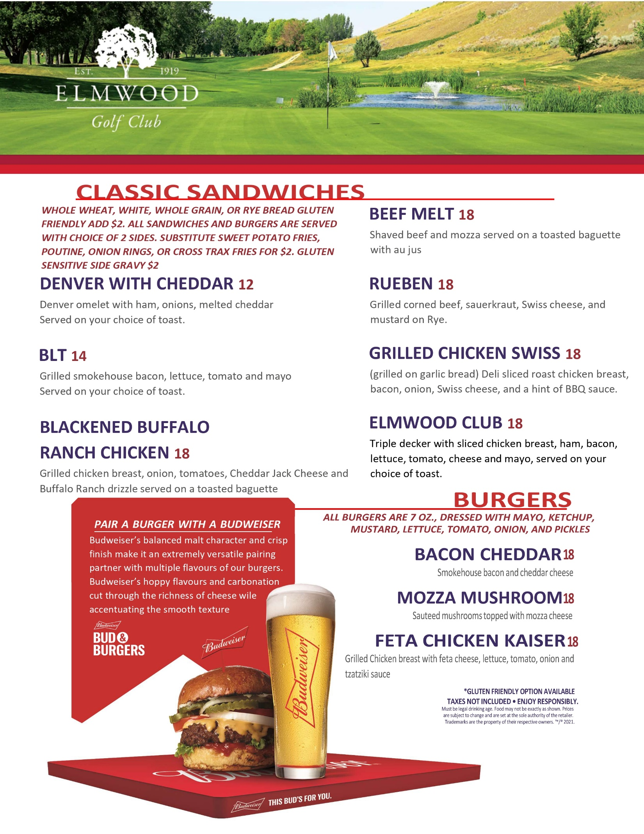
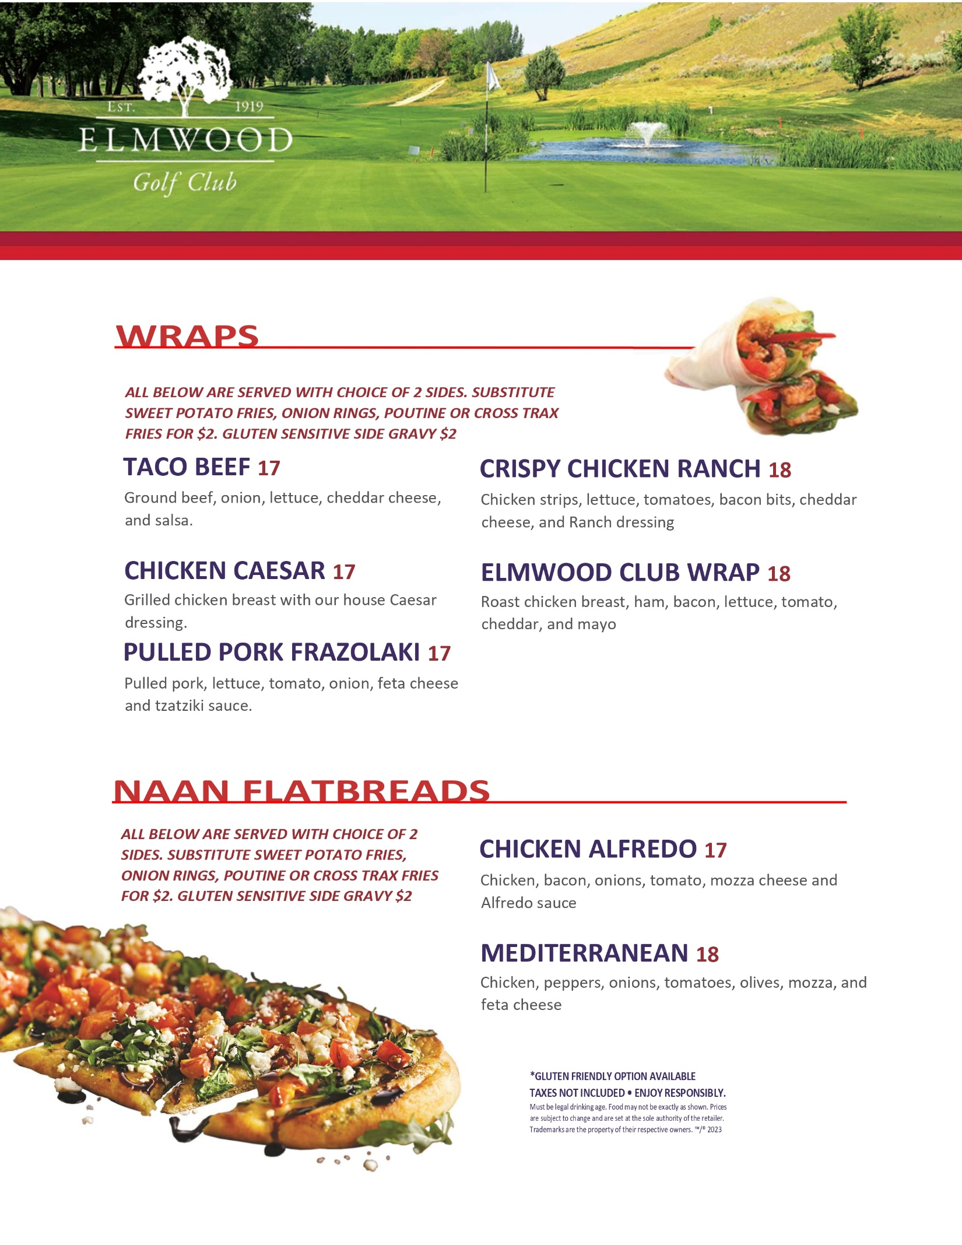
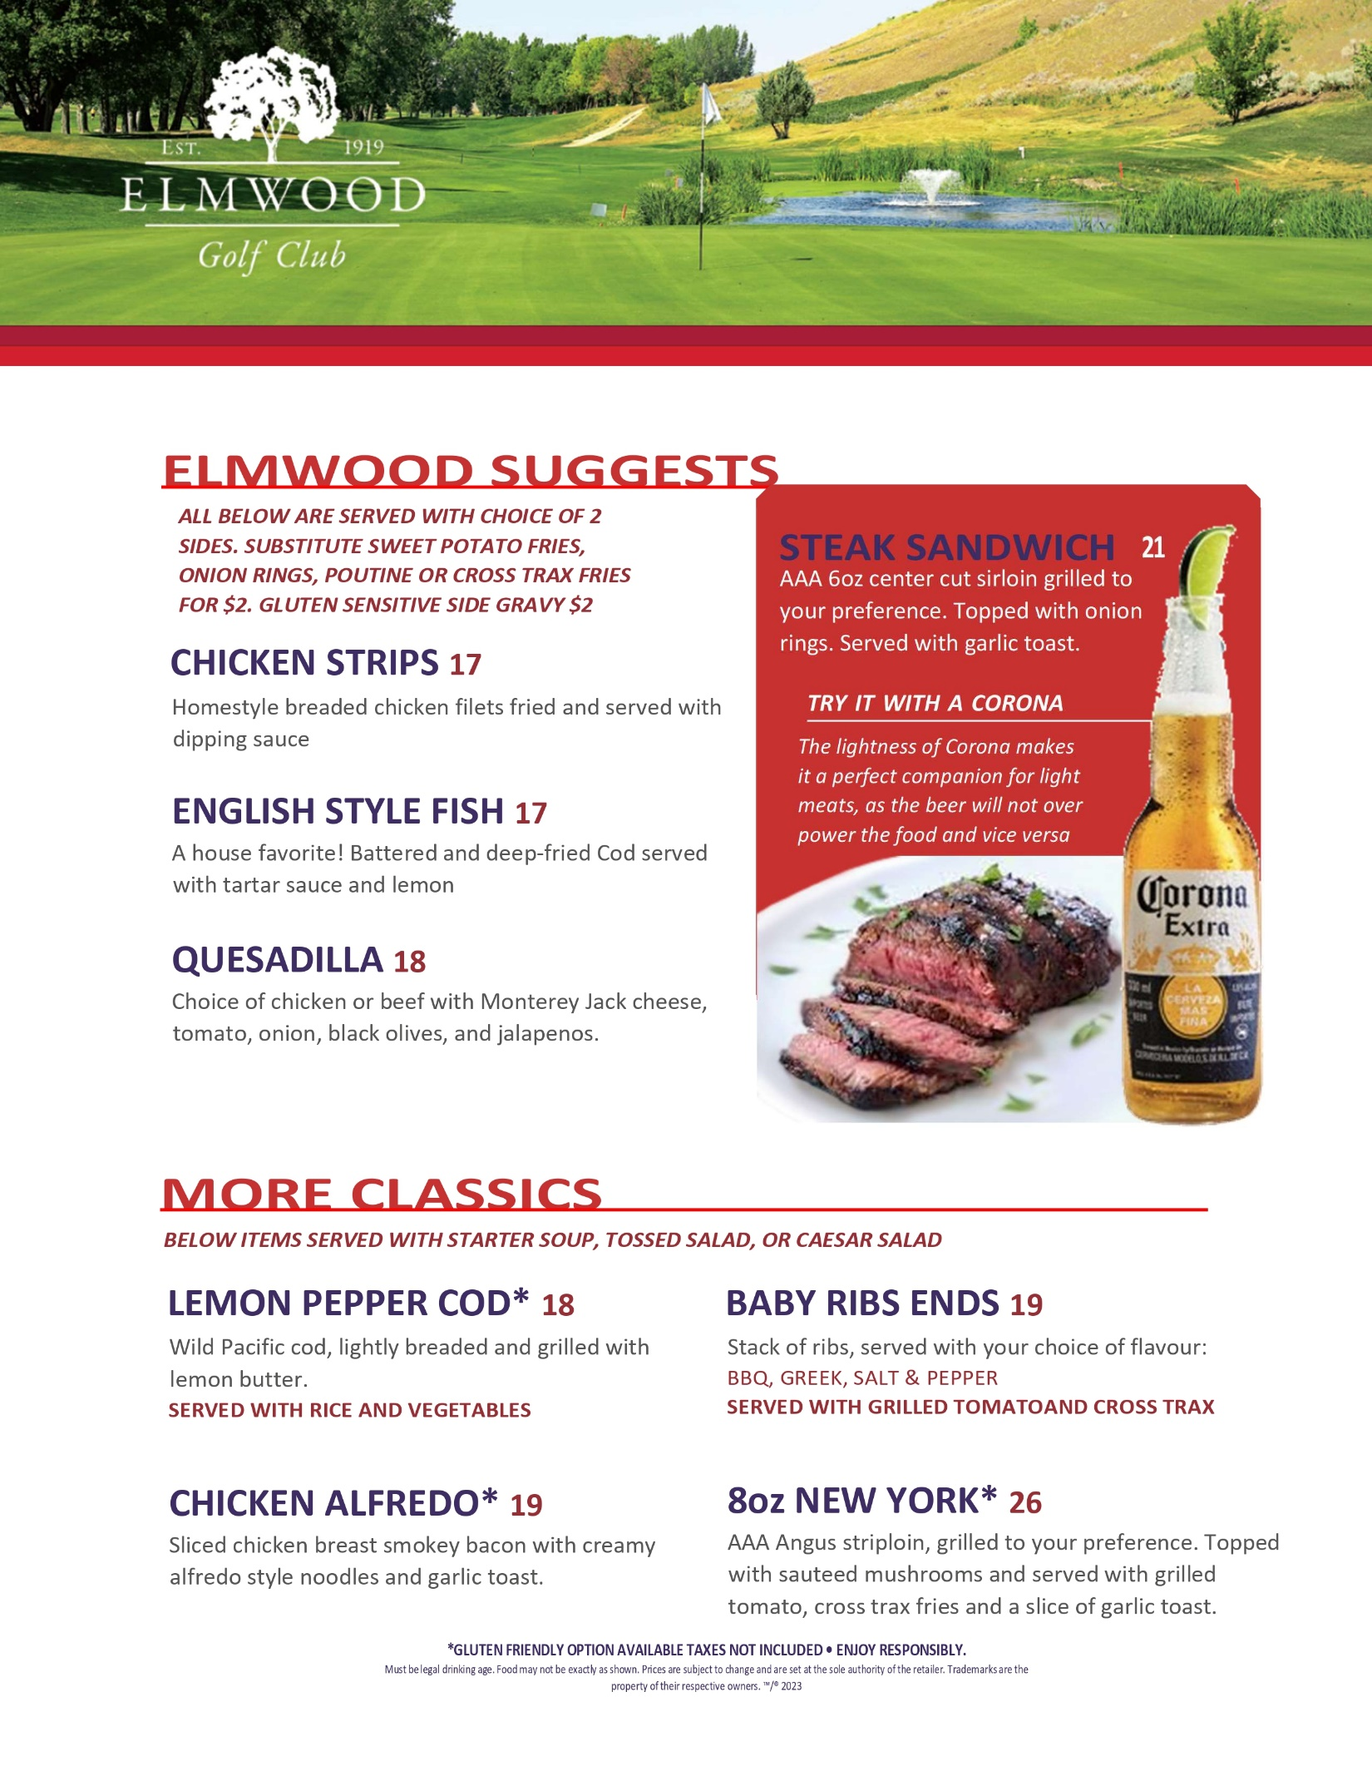
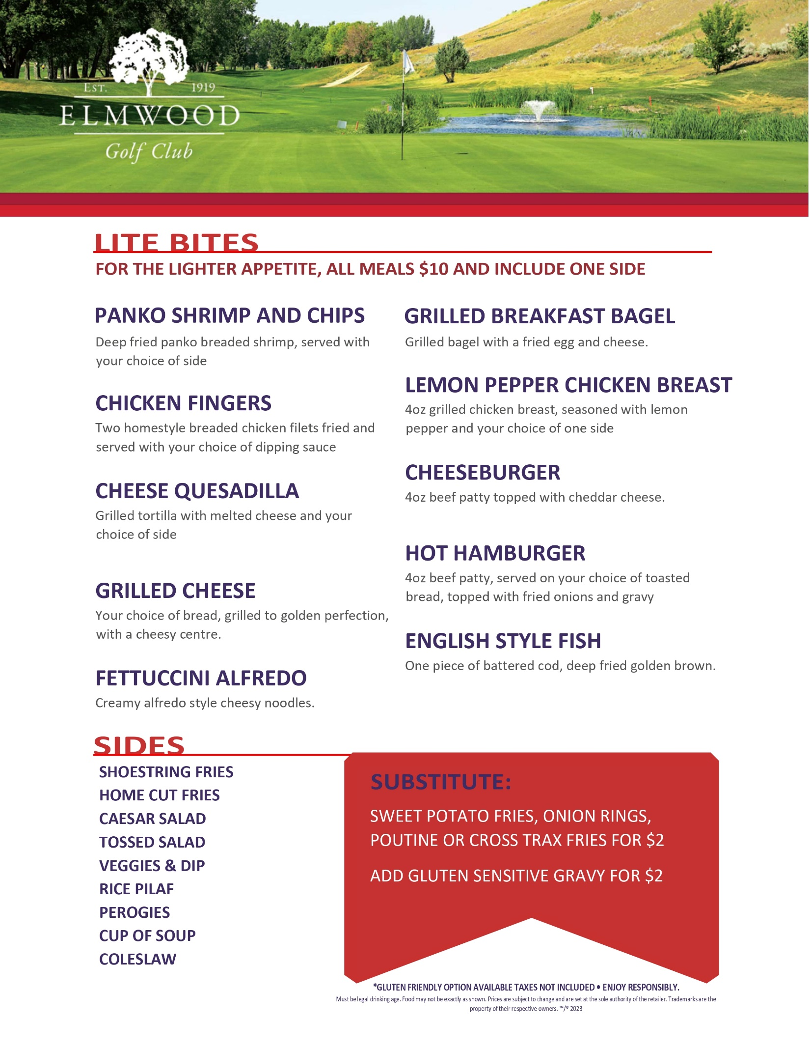

MENU: OUR MENUS ARE SUGGESTIONS ONLY. THE LOUNGE MANAGER, LOUIE DOULIAS, WOULD BE PLEASED TO DESIGN A MENU TO MEET YOUR SPECIFIC NEEDS. FOR MORE INFORMATION, VISIT WWW.ELMWOODGC.COM

ROOM CAPACITIES: THE CEDAR ROOM CAN HOLD UP TO 40 PEOPLE, WHILE THE RESTAURANT CAN HOLD UP TO 160

EVENT CONFIRMATION:IN ORDER TO PROVIDE YOU WITH THE BEST POSSIBLE SERVICE, CONFIRMATION NUMBERS FOR MEAL FUNCTIONS ARE REQUIRED 1 WEEK PRIOR TO YOUR EVENT. IF YOUR CONFIRMATION NUMBER IS NOT RECEIVED YOU WILL BE BILLED FOR THE ORIGINAL NUMBER OF GUESTS FOR WHICH THE FUNCTION WAS BOOKED, OR THE ACTUAL NUMBER IN ATTENDANCE, WHICHEVER IS GREATER. PLEASE DIRECT QUESTIONS TO LOUIE DOULIAS.

FOOD SERVICE: DUE TO PUBLIC HEALTH REGULATIONS, ANY FOOD LEFT OVER FROM FUNCTIONS IN THE BANQUET ROOMS CANNOT LEAVE THE PREMESIS. ELMWOOD GOLF COURSE DOES NOT ALLOW OUTSIDE FOOD OR DRINK BROUGHT IN FROM OFF ON THE PROPERTY UNDER ANY CIRCUMSTANCES.

GRATUITIES: ELMWOOD GOLF CLUB SETS A MINIMUM TIP POLICY OF 15% ON ALL BANQUET/EVENT FOOD PURCHASES (EXCLUDES ALCHOLIC BEVERAGES), BUT RECOMMEND TIPS SHOULD BE DETERMINED BASED ON FOOD QUALITY AND LEVEL OF SERVICE. WE WOULD BE HAPPY TO ADDRESS ANY COMMENTS OR CONCERNS IF THEY SHOULD ARRISE AND WELCOME YOUR FEEDBACK.

OFF SEASON BOOKING: PLEASE CONTACT LOUIE D’S CATERING AT 306-774-6677

2023 RENTAL RATE FOR THE CEDAR ROOM IS $150. ELMWOOD GOLF CLUB MEMBERS RECEIVE COMPLIMENTARY RESERVATION OF THE CEDAR ROOM UPON CONFIRMED FOOD & BEVERAGE ORDER FOR THE EVENT.

FINAL PAYMENT: FINAL PAYMENT IS DUE THE DAY OF, IMMEDIATELY FOLLOWING THE EVENT VIA CREDIT CARD OR PAYMENTS CAN BE ARRANGED VIA CASH OR CHEQUE IF AGREED UPON BY THE LOUNGE MANAGER. IF EVENT IS BOOKED WITH A GOLF TOURNAMENT, PAYMENT FOR GREEN FEES IS DUE IMMEDIATELY UPON CHECK IN PRIOR TO TEE OFF, UNLESS SPECIAL ARRANGEMENTS ARE MADE WITH THE DIRECTOR OF GOLF.

PLEASE PRINT AND SIGN A COPY OF OUR TERMS AND CONDITIONS AND RETURN AS SOON AS POSSIBLE TO CONFIRM YOUR EVENT BOOKING. YOU MAY ALSO CALL OUR LOUNGE MANAGER LOUIE DOULIAS AT 306-774-6677 WITH REGARDS TO AVAILABLE DATES AND MENU CHOICES

CUSTOMER SIGNATURE__________________________________________ DATE_____________________

EVENT DATE & TIME REQUESTED________________________________

GOLF BOOKING PROCEDURES & POLICIES

FINAL PAYMENT: FINAL PAYMENT IS DUE THE DAY OF, IMMEDIATELY FOLLOWING THE EVENT VIA CREDIT CARD OR PAYMENTS CAN BE ARRANGED VIA CASH OR CHEQUE IF AGREED UPON BY THE LOUNGE MANAGER. IF EVENT IS BOOKED WITH A GOLF TOURNAMENT, PAYMENT FOR GREEN FEES IS DUE IMMEDIATELY UPON CHECK IN PRIOR TO TEE OFF, UNLESS SPECIAL ARRANGEMENTS ARE MADE WITH THE DIRECTOR OF GOLF.

PACE OF PLAY: FOR THE ENJOYMENT OF OUR GUESTS, TOURNAMENT GROUPS ARE REQUIRED TO COMPLETE THEIR ROUND WITHIN A MAXIMUM OF 5 HOURS. A RECOMMENDED PACE OF PLAY IS 4 HOURS AND 20 MINUTES. PLAYERS ASSISTANTS WILL BE ON THE COURSE TO HELP MAINTAIN THIS STANDARD OR PROVIDE ASSISTANCE TO PLAYERS IF NEEDED

FINAL NUMBERS: EACH TOURNAMENT MUST SUBMIT FINAL PLAYER NUMBERS AT LEAST ONE WEEK PRIOR TO THE EVENT. SMALL CHANGES WILL BE ACCEPTED UP TO 48 HOURS IN ADVANCE. TOURNAMENTS WILL BE CHARGED FOR TEE TIMES BOOKED IF THOSE PLAYERS FAIL TO ATTEND THEIR EVENT. SPECIAL ARRANGEMENTS CAN BE MADE WITH EACH EVENT ONLY WITH APPROVAL FROM THE DIRECTOR OF GOLF. ELMWOOD GOLF COURSE RESERVICES THE RIGHT TO CHANGE OR ALTER TEE TIMES, START TIMES, COURSE ROTATION OR FORMAT SHOULD THE NUMBER OF PLAYERS DIFFER GREATLY FROM THE ORIGINAL BOOKING.

SHOTGUN STARTS: THE MINIMUM NUMBER OF PLAYERS REQUIRED FOR A 9 HOLE SHOTGUN START IS 72. THE MINIMUM NUMBER OF PLAYERS FOR AN 18 HOLE SHOTGUN IS 120+. IF YOU DECIDE TO GO AHEAD WITH A SHOTGUN START FOR LESS THAN THE REQUIRED NUMBER OF PLAYERS, YOU WILL BE BILLED FOR THE EQUIVILANT OF NUMBER OF GREEN FEES AND CART FEES FOR TO MEET THE MINIMUM NUMBER. THE MAXIMUM COURSE CAPACITY IS 144 GOLFERS FOR EACH SHOTGUN ORGANIZED IN GROUPS OF 4. TOURNAMENTS MAY DO GROUPS OF 8 IF APPROVED BY THE DIRECTOR OF GOLF PROVIDED PACE OF PLAY IS MAINTAINED.

CANCELLATION POLICY: TOURNAMENTS CANCELLED PRIOR TO 1 WEEK BEFORE THEIR EVENT WILL INCUR NO CHARGES. IF FOOD WAS ORDERED, EVENTS MUST PROVIDE PAYMENT REGARDLESS OF WHETHER THE EVENT TAKES PLACE. IF OUTSIDE GOLF CARTS WERE BOOKED, THE EVENT IS RESPONSIBLE FOR PAYMENT IF CHARGES ARE INCURRED BY ACEOFCARTS, OUR TOURNAMENT CART PROVIDER. SMALL CHANGES CAN BE MADE TO PLAYER NUMBERS ON A CASE BY CASE BASIS ONLY UPON APPROVAL BY THE DIRECTOR OF GOLF OR GENERAL MANAGER. TOURNAMENTS ARE EXPECTED TO PLAY IN INCLIMENT WEATHER. THE ONLY TIME THE COURSE WILL CLOSE IS DUE TO LIGHTNING OR SEVERE WEATHER WARNINGS AS RELEASED BY ENVIRONMENT CANADA. WE RECOMMEND YOUR EVENT PURCHASE EVENT CANCELLATION INSURANCE THROUGH YOUR INSURANCE PROVIDER.

PAYMENT INFORMATION: TOURNAMENTS WILL BE CONFIRMED ONLY BY RECEPT OF A 25% DEPOSIT. DEPOSIT MAY BE WAIVED BY DIRECTOR OF GOLF ON A CASE BY CASE BASIS. ALL CANCELLATIONS MUST BE RECEIVED IN WRITING. YOU WILL BE INVOICED THE DAY OF THE EVENT, IMMEDIATELY FOLLOWING CHECK-IN. PAYMENT IS DUE UPON RECEIPT OF THE INVOICE AND MAY BE MADE BY CHEQUE OR CREDIT CARD. 2% PER MONTH INTEREST (24% PER ANNUM) WILL BE CHARGED ON OVERDUE BALANCES. INVOICES OVER 30 DAYS LATE WILL BE CONSIDERED OVERDUE. IF YOU ARE UNABLE TO MEET THESE PAYMENT TERMS, PLEASE ADVISE THE DIRECTOR OF GOLF SO ALTERNATE ARRANGEMENTS CAN BE MADE.

PRIZES: ELMWOOD GOLF CLUB OOES NOT HAVE A MINIMUM SPEND PER PLAYER BUT TOURNAMENTS ARE ENCOURAGED TO PURCHASE PRIZES OUT OF THE GOLF SHOP. WE WILL MATCH OR BEAT ANY GOLF TOWN PRICE AND CAN SOURCE A WIDE VARIETY OF GOLF AND NON GOLF PRIZES.

WEATHER: IN CASE OF COLD AND/OR INCLEMENT WEATHER, TOURNAMENT PLAY AND MEALS MUST GO AHEAD AS SCHEDULED UNLESS THE GOLF COURSE IS DEEMED UNPLAYABLE OR LIGHTNING BECOMES A SAFETY HAZARD AS DETERMINED BY COURSE MANAGEMENT. IF THE COURSE IS TOO WET FOR POWER CARTS, THE EVENT IS EXPECTED TO CONTINUE AS A WALKING ONLY OR CART PATH ONLY EVENT WITH STRICT ENFORCEMENT. IN THE EVENT OF AN OCCURANCE OF WEATHER THAT RESULTS IN THE COURSE BEING UNPLAYABLE, THE TOURNAMENT WILL BE GIVEN, WHEREVER POSSIBLE, ALTERNATE DAYS OF PLAY. IF ALTERNATE DATES ARE NOT AVAILABLE, THE DAYS FEES WOULD BE REFUNDED, EXCEPT FOR FOOD AND BEVERAGE CHARGES. WE RECOMMEND EVENT CANCELLATION INSURANCE THROUGH YOUR INSURANCE PROVIDER IF YOU DEEM IT APPROPRIATE.

DAMAGES: THE TOURNAMENT HOST IS RESPONSIBLE FOR THE ACTIONS OF ITS TOURNAMENT PARTICIPANTS AND WILL INDEMNIFY AND SAVE ELMWOOD GOLF CLUB FROM ALL LOSSES, DAMAGES, AND CLAIMS WHATSOEVER WHICH ELMWOOD GOLF CLUB SUFFERS OR INCURS AS A RESULT OF ANY ACT, NEGLECT OR OMISSION OF THE TOURNAMENT PARTICIPANTS. ELMWOOD GOLF CLUB SHALL NOT BE RESPONSIBLE FOR ANY LOSS OR INJURY SUFFERED OR INCURRED BY ANY TOURNAMENT PARTICIPANT UNLESS SUCH LOSS OR INJURY IS CAUSED BY THE NEGLIGENCE OR WILLFUL WRONGFUL ACT OF ELMWOOD GOLF CLUB OR ITS EMPLOYEES. TOURNAMENT PARTICIPANTS ARE RESPONSIBLE FOR ANY DAMAGE CAUSED TO PERSONAL RESIDENCES ADJACENT TO THE GOLF COURSE (EX. BROKEN WINDOWS) IN THE EVENT THAT A PARTICIPANT HAS DAMAGED SAID PROPERTY, AND NEGLECTS TO INFORM THE TOURNAMENT ORGANIZER, THE ORGANIZER WILL BE RESPONSIBLE FOR ALL COSTS ASSOCIATED WITH THE DAMAGE. THE TOURNAMENT HOST IS RESPONSIBLE FOR ANY DAMAGES TO POWER CARTS, THE GOLF COURSE, THE CLUBHOUSE OR ANY FIXED PROPERTY OF ELMWOOD GOLF CLUB. IN THE EVENT OF DAMAGE TO A GOLF CART THAT RESULTS IN ELMWOOD BEING UNABLE TO RENT THAT CART WHILE REPAIRS ARE BEING MADE, THE TOURNAMENT ORGANIZER WILL BE CHARGED A FLAT FEE OF $200 FOR LOST CART RENTAL REVENUE FOR EACH WEEKEND THAT THE GOLF CART IS UNABLE TO BE RENTED, TO A MAXIMUM OF $1000. ELMWOOD GOLF CLUB RECOMMENDS PURCHASING OF EVENT INSURANCE TO MANAGE ANY RISK THAT MAY OR MAY NOT BE INCURED BY THE TOURNAMENT ORGANIZER. LOST OR NEGLIGENT DAMAGE TO RENTAL CLUBS WILL BE CHARGED TO THE INDIVIDUAL OR THE TOURNAMENT HOST (DEPENDING ON WHO IS RESPONSIBLE FOR THE RENTAL FEE). ELMWOOD GOLF CLUB IS NOT RESPONSIBLE FOR ANY MISPLACED OR DAMAGED SIGNAGE. PLEASE HAVE ALL SIGNAGE DROPPED OF THE DAY BEFORE YOUR EVENT AND PICKED UP WITHIN 24 HOURS OF YOUR TOURNAMENT.

PHOTOGRAPHY: ELMWOOD GOLF CLUB DOES NOT CHARGE FOR PHOTOGRAPHY ON THE GOLF COURSE. PHOTOGRAPHERS ARE EXPECTED TO STAY OUT OF THE WAY OF GOLFERS AS THEY PLAY THEIR ROUND.

STORAGE: ELMWOOD GOLF CLUB HAS LIMITED STORAEG SPACE BUT CAN PROVIDE SPACE FOR THE TOURNAMENT IF REQUESTED

POWER CARTS: POWER CARTS ARE REQUIRED FOR ALL TOURNAMENTS. IF YOU REQUIRE MORE THAN 40 GOLF CARTS, ADDITIONAL CARTS CAN BE BROUGHT IN AT A COST OF $115/CART. ELMWOOD GOLF CLUB WILL ENSURE THEY HAVE ENOUGH POWER CARTS FOR YOU BASED ON THE MAXIMUM NUMBER OF PLAYERS THE COURSE CAN ACCOMMODATE, SUBJECT TO CART AVAILABILITY THROUGH ACE OF CARTS. PLEASE RESERVE ALL REQUIRED CARTS AT THE TIME OF BOOKING. EVENT ORGANIZERS ARE ENCOURAGED TO RESERVE ANY CARTS REQUIRED OVER 40 BY SPEAKING TO ACE OF CARTS IN SASKATOON DIRECTLY. POWER CARTS MUST BE KEPT AWAY FROM TEES AND GREENS. THE COURSE WILL BE ROPED OFF AND/OR SIGNED WHERE CARTS ARE NOT PERMITTED. PLAYER ASSISTANTS AND STARTERS HAVE SOLE AUTHORITY ON THE GOLF COURSE. PLEASE OBEY ALL INSTRUCTIONS AND/OR REQUESTS.

FOOD AND BEVERAGE: MENU SELECTION MUST BE CONVEYED AT LEAST 2 WEEKS PRIOR TO YOUR EVENT. FINAL NUMBERS MUST BE PROVIDED ONE WEEK PRIOR TO YOUR EVENT. THE CONFIRMED NUMBER WILL BE YOUR GUARANTEE. YOU WILL BE CHARGED FOR THE GUARANTEED NUMBER OR THE ACTUAL NUMBER, WHICHEVER IS GREATER. ANY ADDITIONS MUST BE APPROVED BY LOUIE DOULIAS. THE NUMBER OF CONFIRMED MEALS CANNOT BE LESS THAN THE NUMBER OF CONFIRMED GOLFERS. ALL F&B SUBJECT TO 11% TAX. BANQUET SERVICE INCURS A 15% GRATUITY CHARGE. PRICES ARE SUBJECT TO CHANGE WITHOUT NOTICE. ALL FOOD AND BEVERAGE MUST BE PURCHASED FROM ELMWOOD GOLF CLUB. IT IS THE POLICY OF THE CLUB TO SERVE ALCOHOLIC BEVERAGES IN A RESPONSIBLE AND PROFESSIONAL MANNER AT ALL TIMES. WE ADHERE TO ALL APPLICABLE LAWS AND REGULATIONS AS THEY PERTAIN TO THE SERVICE OF ALCOHOL TO UNDERAGE OR VISIBLY INTOXICATED PERSONS. ELMWOOD RESERVES THE RIGHT TO REFUSE SERVICE. HOURS OF SERVICE FOR ALCOHOLIC BEVERAGES BEGINS AT 10AM. ALL ALCOHOLIC BEVERAGES MUST BE PURCHASED FROM GOLF COURSE PERSONEL. OUTSIDE ALCOHOL WILL BE CONFISCATED AND THE PERSON(S) RESPONSIBLE WILL BE ASKED TO LEAVE, WITH NO REFUND GIVEN. THIS IS DUE TO SASKACHEWAN GAMING AND LIQUORE LAWS AND COULD RESULT IN A FINE FOR ELMWOOD GOLF CLUB AND/OR THE TOURNAMENT ORGANIZER UP TO OR EXCEEDING 10,000, AND LOSS OF ELMWOOD GOLF CLUBS LIQUOR LICENCE. ALL REGULATIONS WILL BE STRICTLY ENFORCED.

SPECIAL REQUESTS _____________________________________________

Group Name: ...............................................................................

Event Name: .................................................................................

Contact Name: ............................................................................

Number of GOLFERS ...................................................................

Contact Number: ......................................................................

CONTACT EMAIL ADDRESS:……………………...............................

TEE TIME/SHOTGUN TIME REQUESTED: ......................................

Signature/DATE: _____________________/________ (MM/DD/YYYY)

