2019 Elmwood’s
“Learn to Compete” on course
Golf Program

Must have some experience in playing golf and is ready to learn rules and etiquette and general course play to start playing golf regularly.
This golf program is for kids that can already hit the ball pretty good for their age and it’s time to spend more time on the course learning to play and compete in the game of golf. Cost is $180 and includes all range, golf course fees and a new golf shirt valued at $60.
Age and times are as follows and are limited to 10 kids in each group: (circle)
9-11 – Thursdays 4pm to 5:30pm, June 6, 13, 20, July 4, 11, 18, 27
12-14 - Thursdays 5:30pm to 7pm, June 6, 13, 20, July 4, 11, 18, 27

Junior Name:_____________________________ Male – Female (please circle)
Age:________(month,day,year) _______ /_______ /__________
Parents Names: _____________________________________________________
Phone#(home)_________________________(cell)_________________________
*Emails*_______________________________ ____________________________
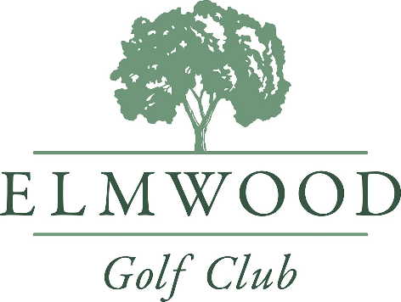
Paid $ 180 by CASH CHEQUE VISA MC DEBIT

